**Count, count_if in C++ STL:**

Note: count, count_if works linear time. If array is already sorted then we can use binary search type algo to count occurrence of an element.

Note: count_if and find_if works on predicates, not on comparators.

Predicates are of two kinds :

unary predicate : takes one argument and return bool.

Binary predicate: takes two arguments and return bool.

All generic algorithms are present in <algorithm>header.

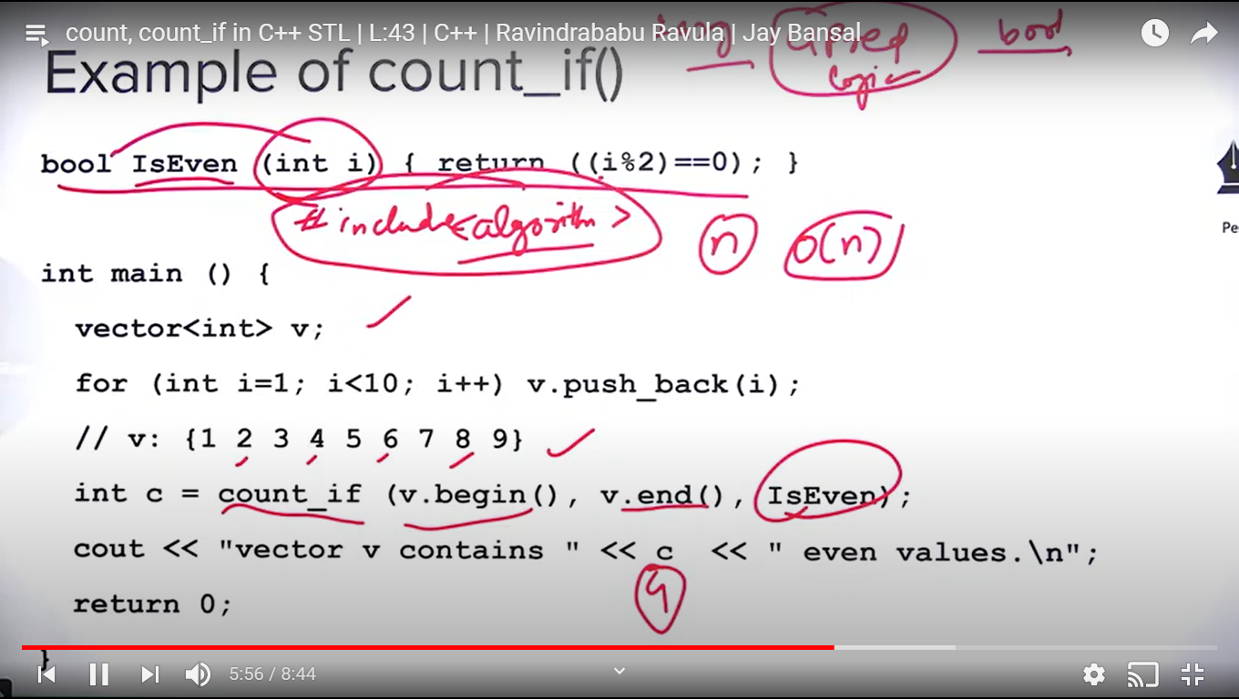

Find and find_if():

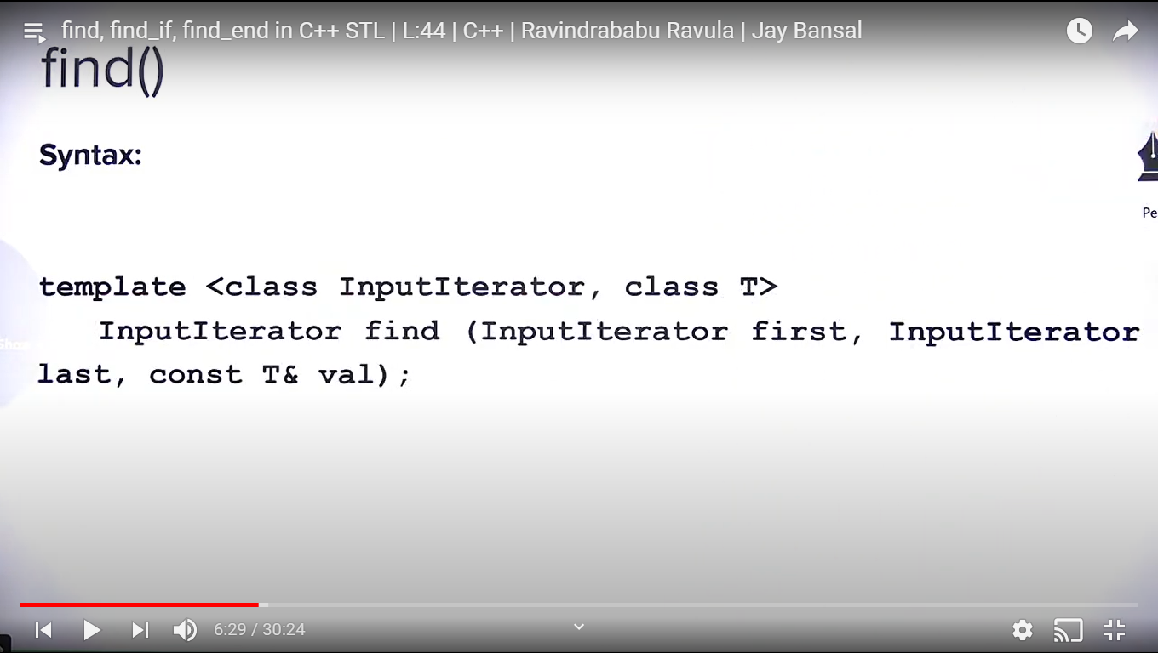

Find returns iterator of first occurrence of the val.

Find() and find_if() functions find the val using linear search so not useful if array is already sorted.

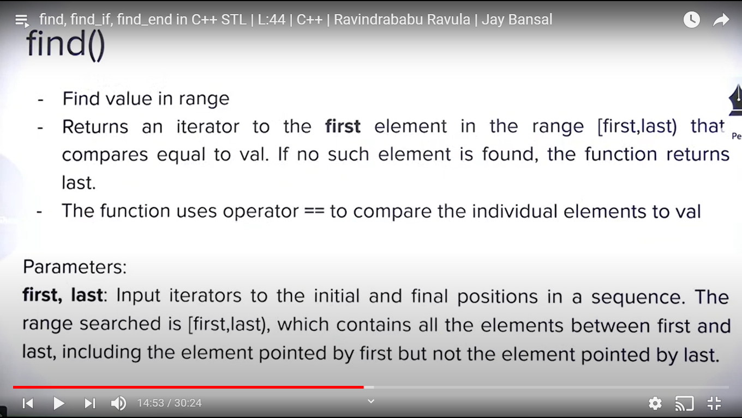

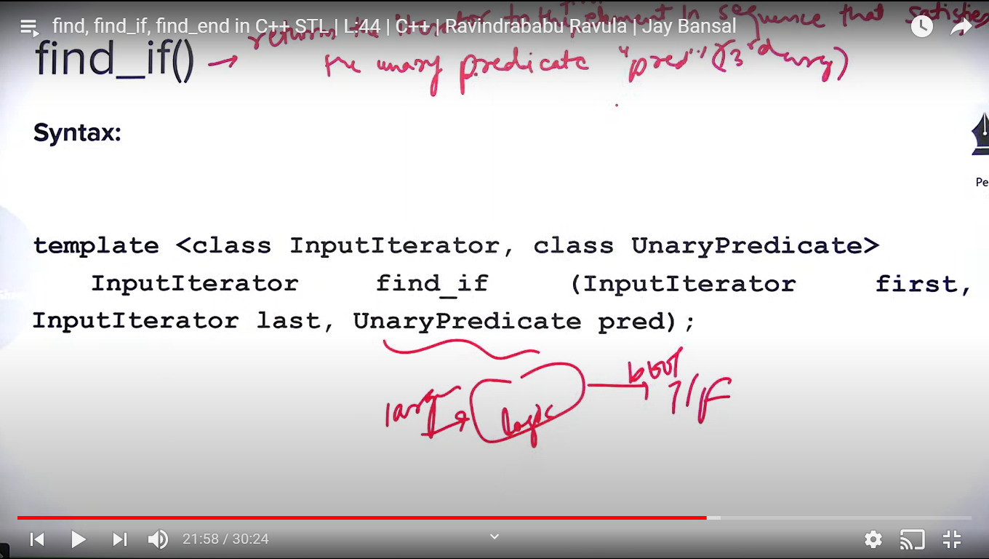

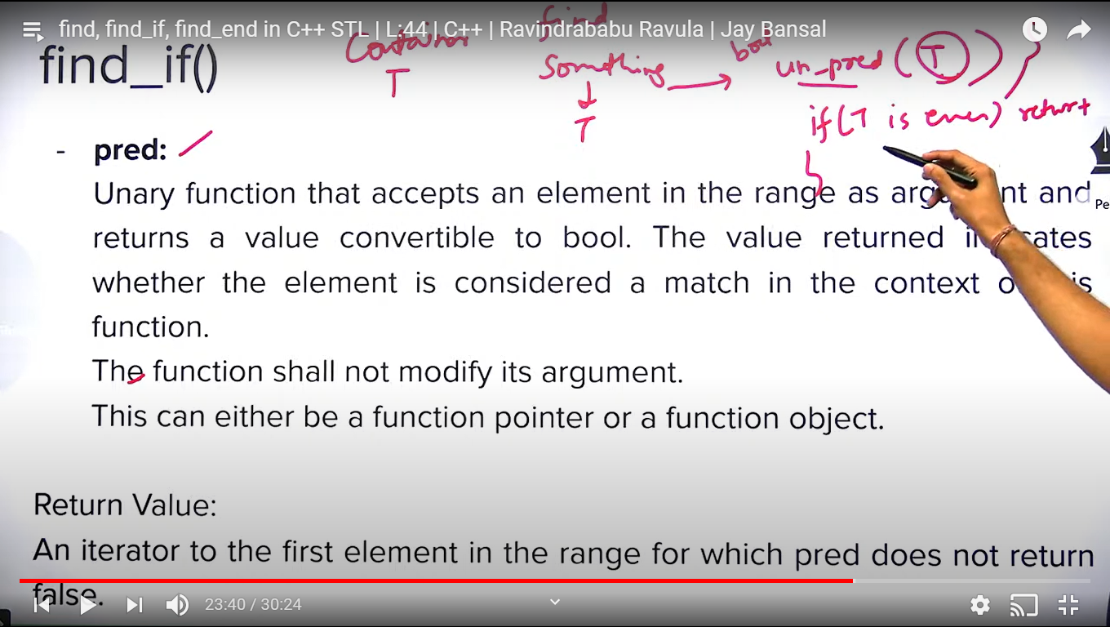

Reverse() and reverse_copy() :

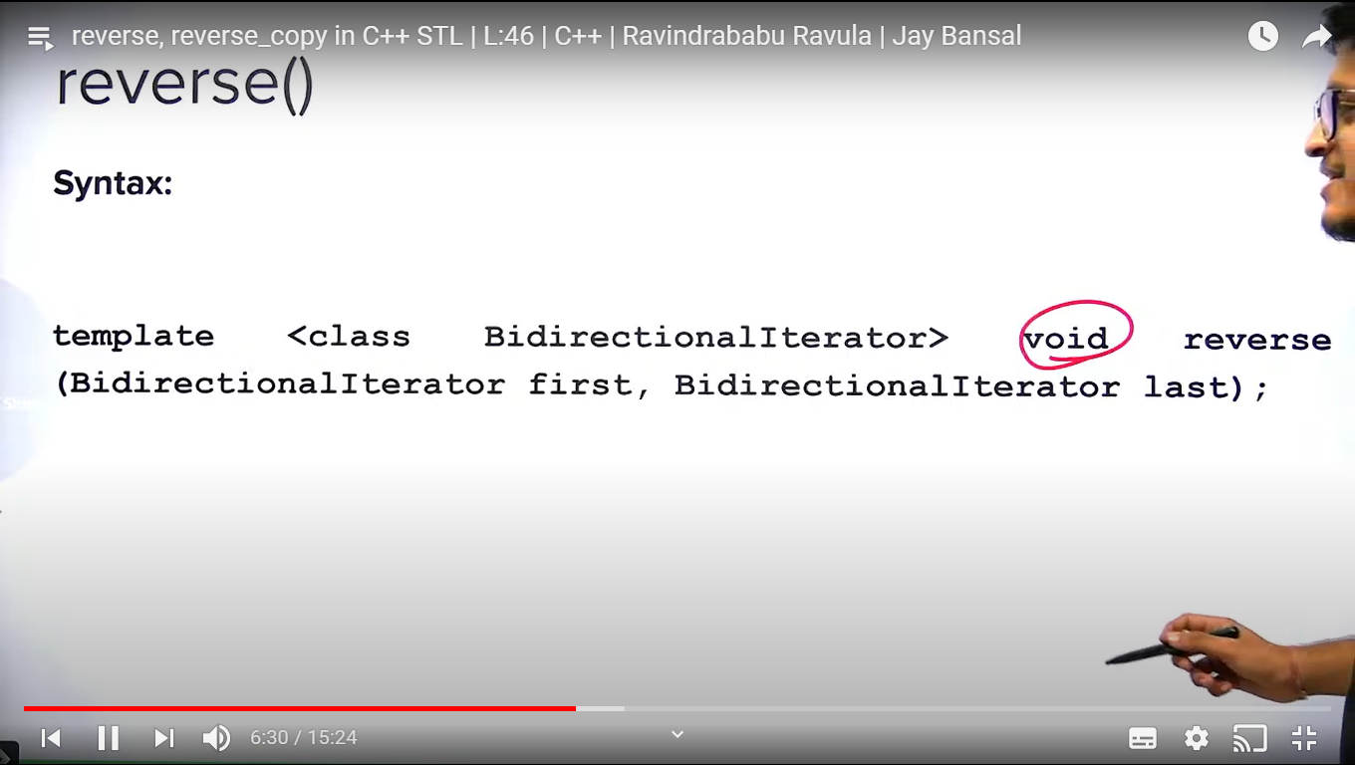

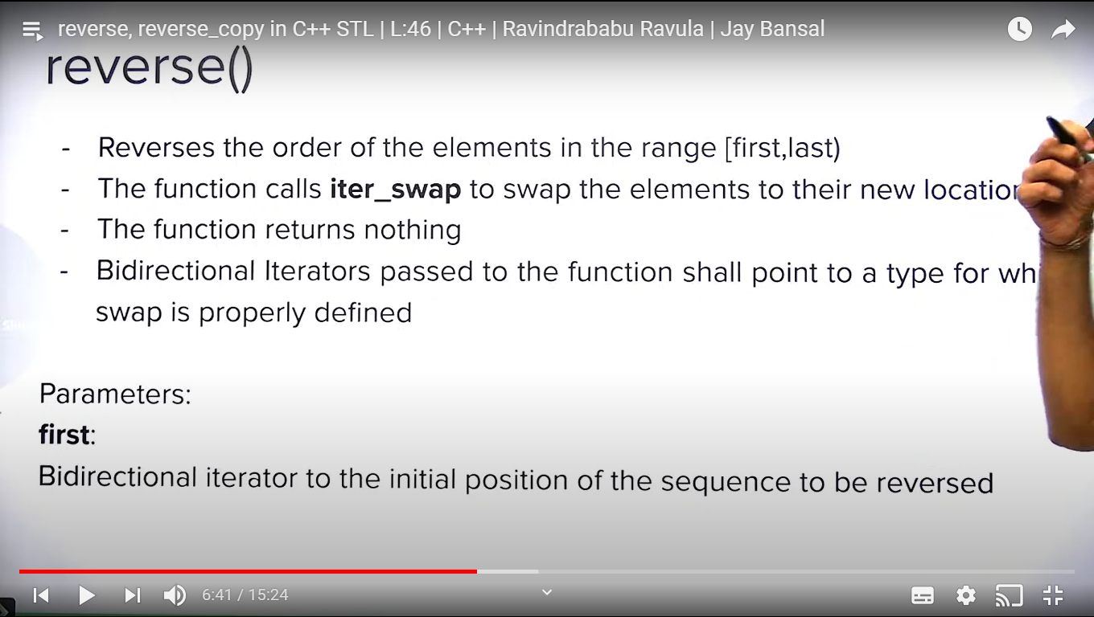

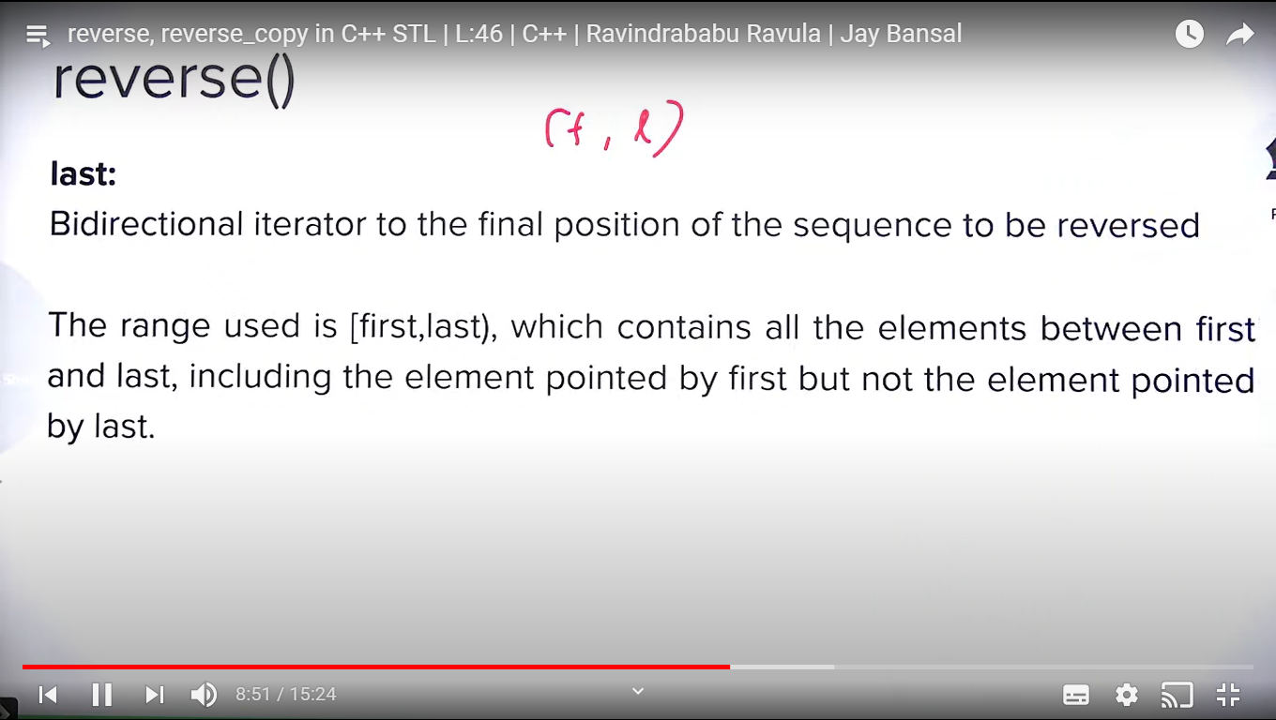

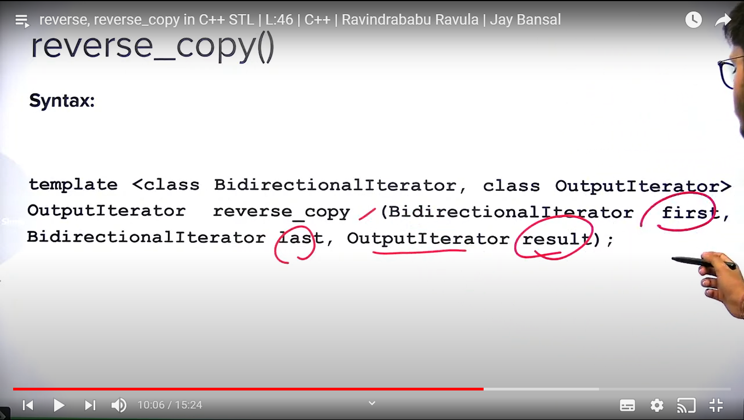

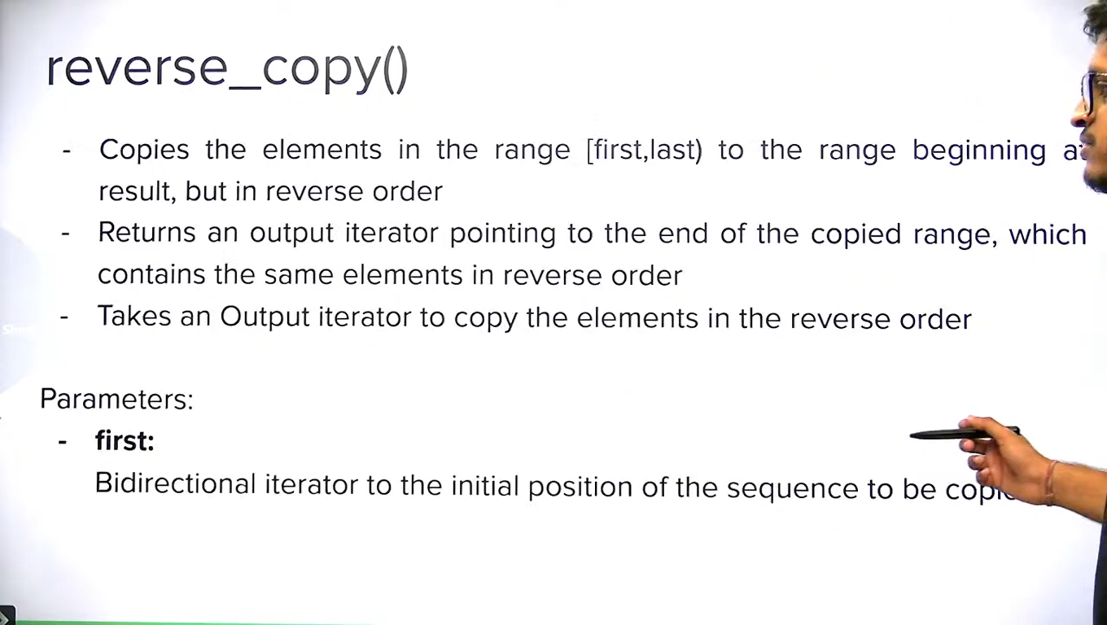

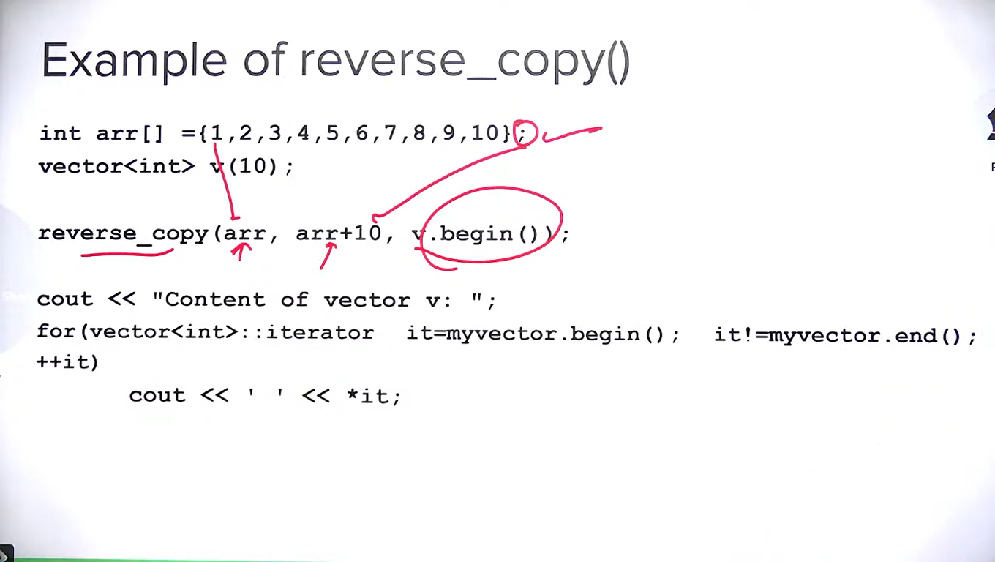

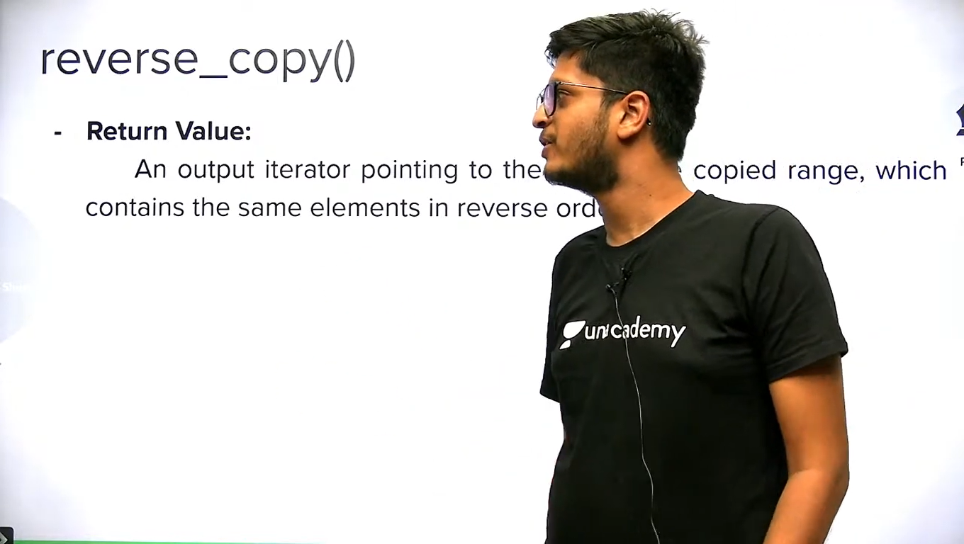

Unique() and unique_copy() :

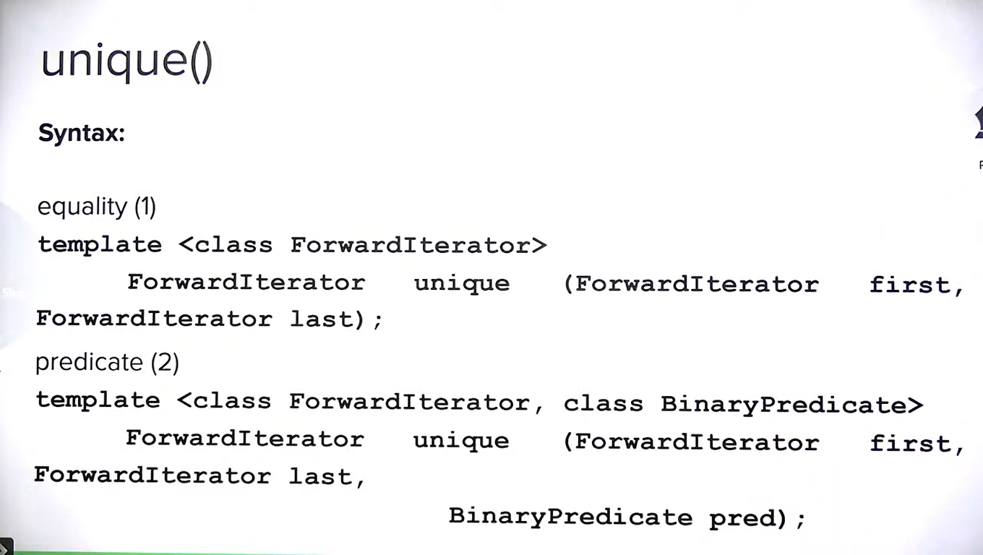

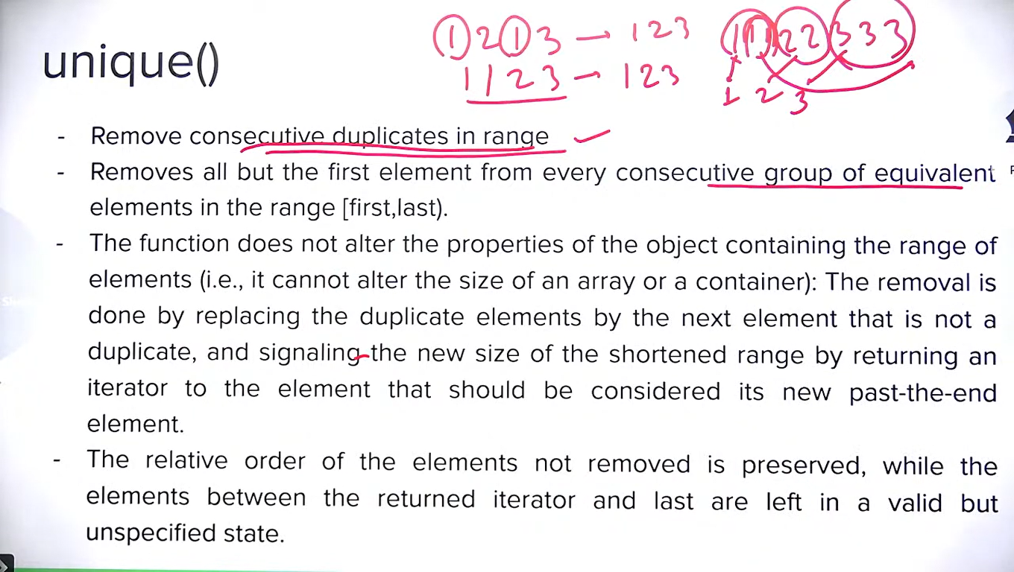

**Note:** unique requires the container to **be sorted** to work as per requirement.

It doesn’t remove the duplicate element so size is not reduced. It just places duplicate elements in the end. After removing the duplicate elements it returns the iterator just after useful vector ends.

It requires binary predicates. If we are not passing predicate, it compares by == operator.

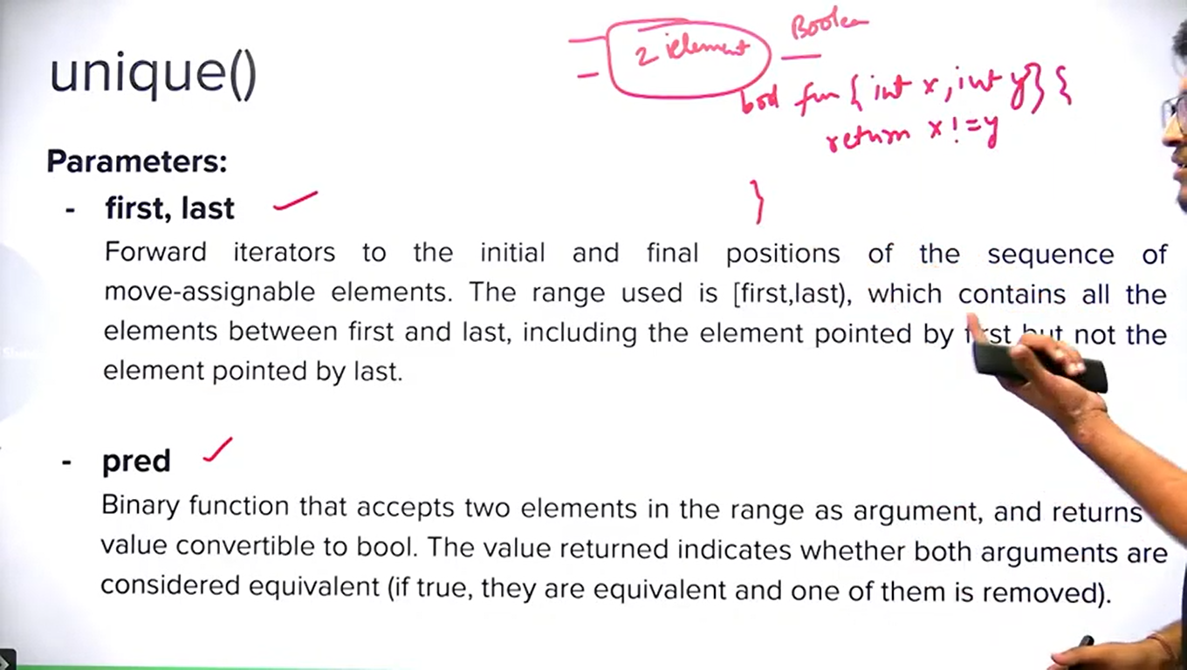

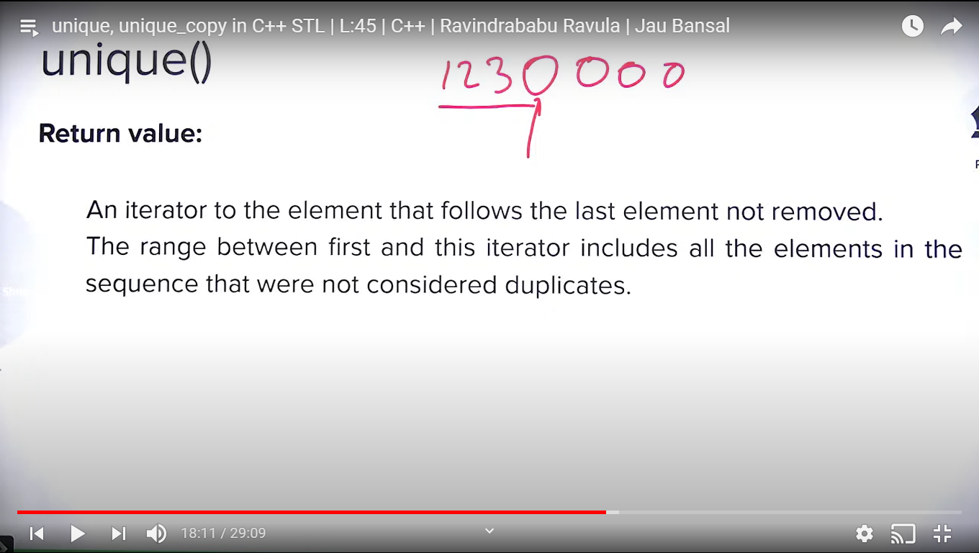

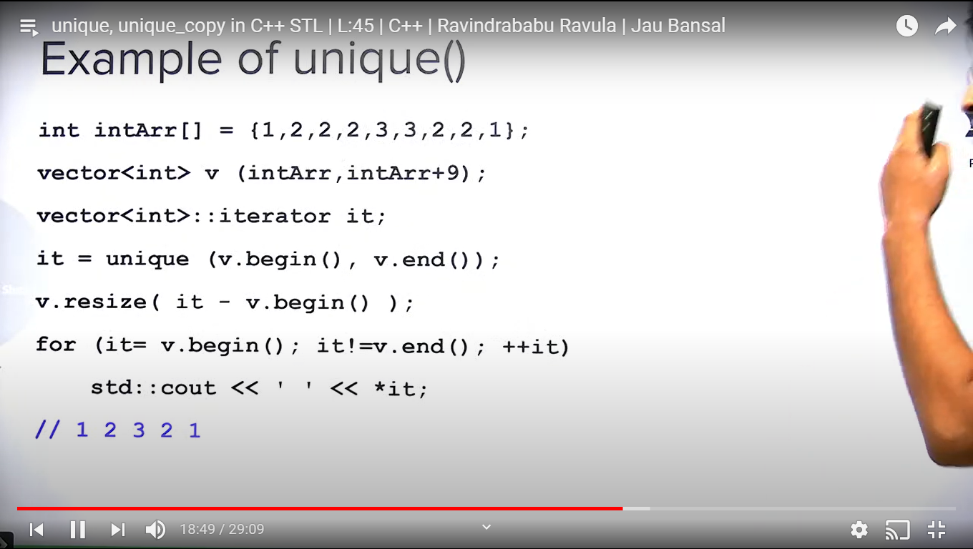

**Note:** pointers are also random access iterator.

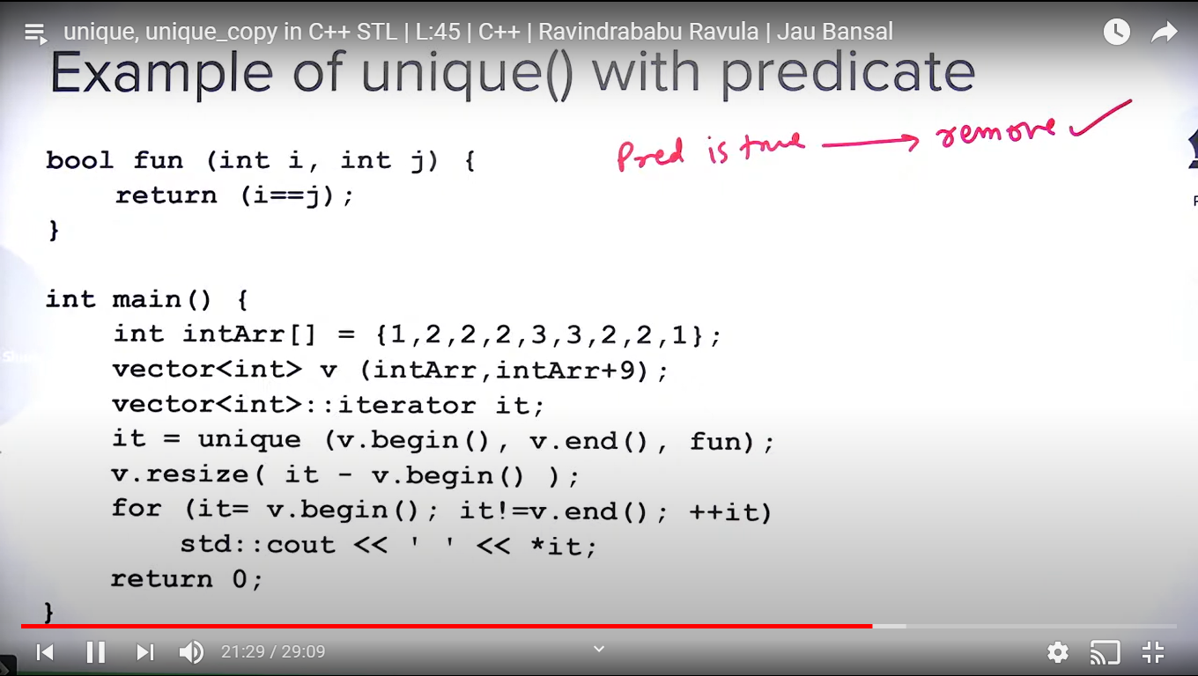

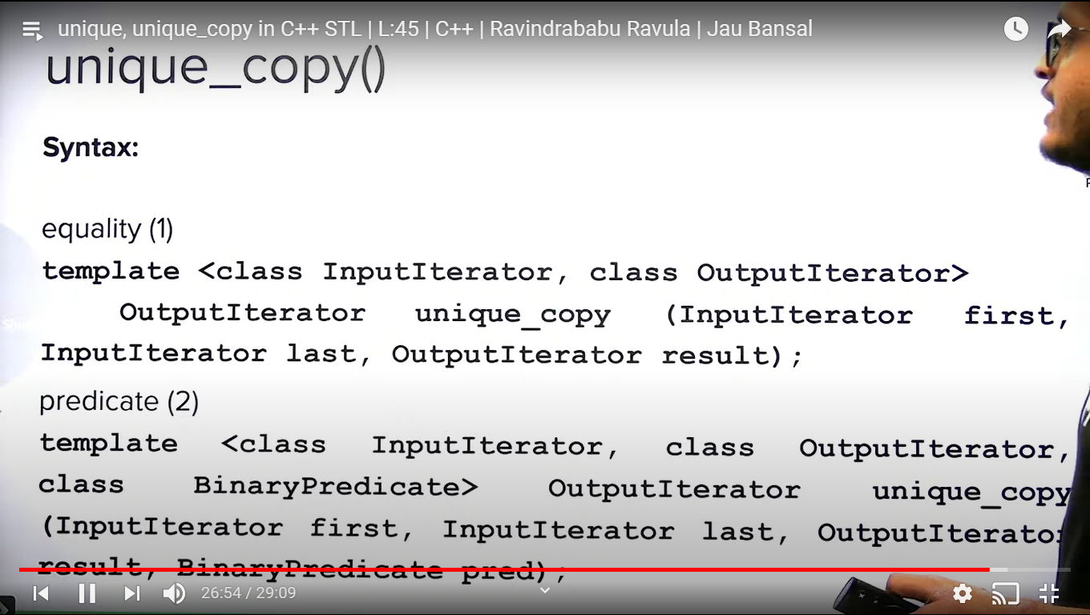

**Transform(), rotate(), rotate_copy():**

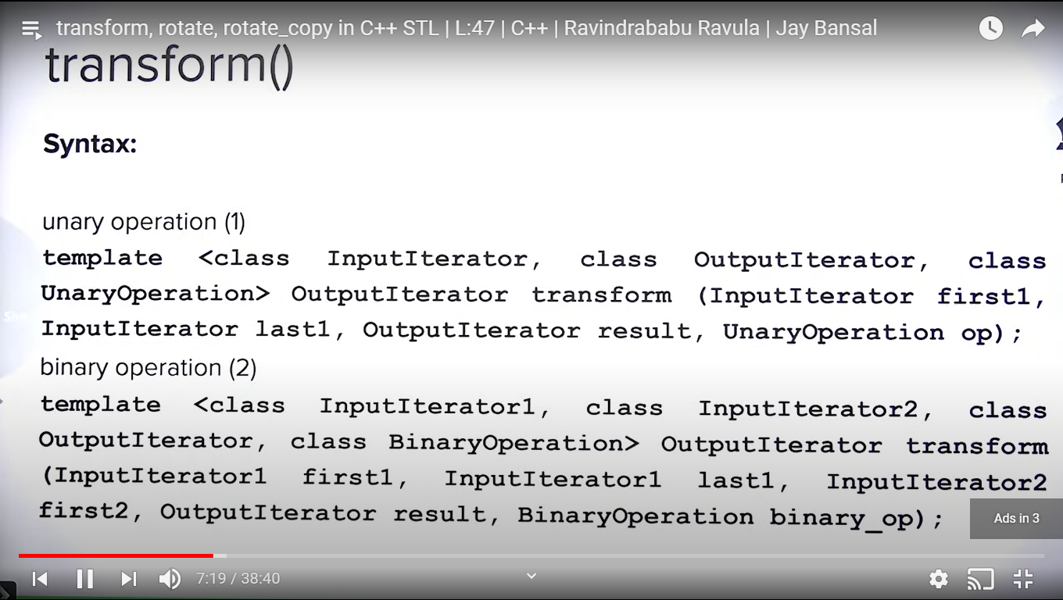

**Note:** transform is more like similar to numpy array in python.

We can define the transformation using unaryoperation or binary operation which will be applied on all the elements.

We need two containers for binaryoperation.

Unaryoperation and binaryoperation are not predicate because these don’t return bool.

Unaryoperation and binaryoperation are also called unary function and binary function.

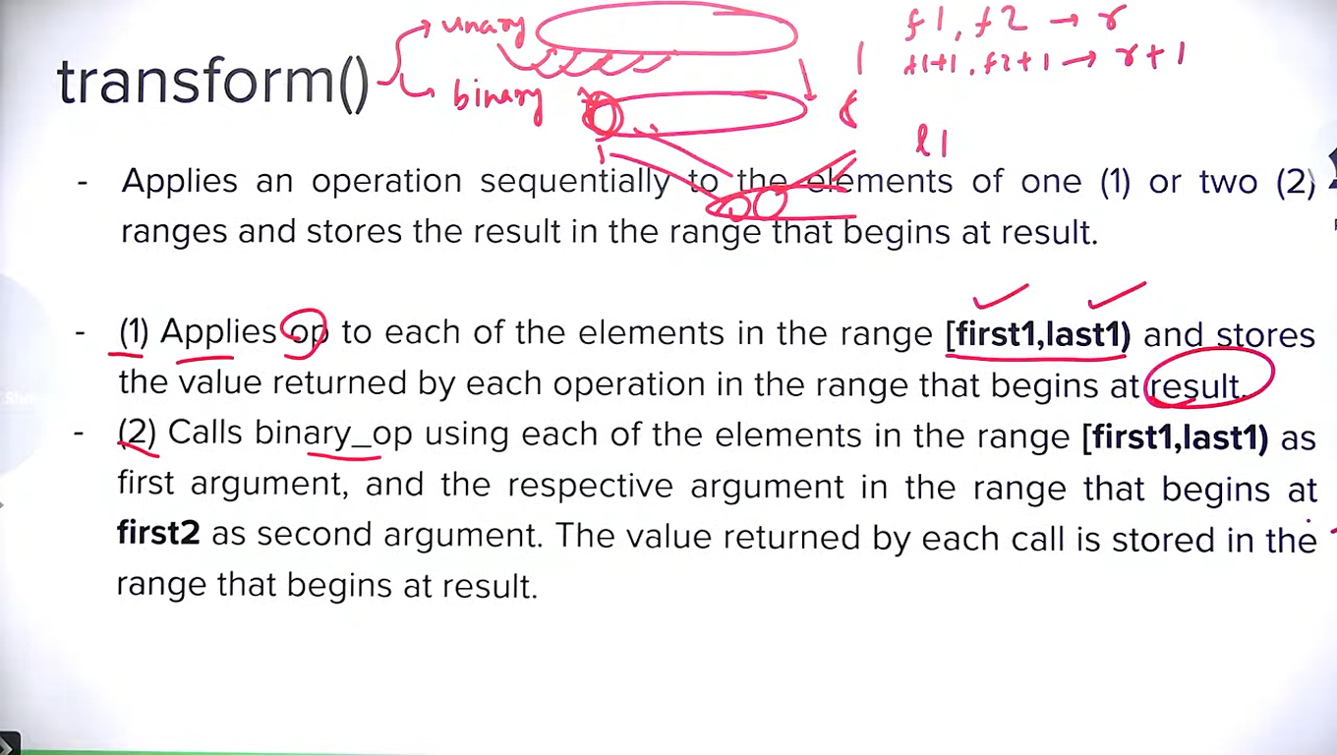

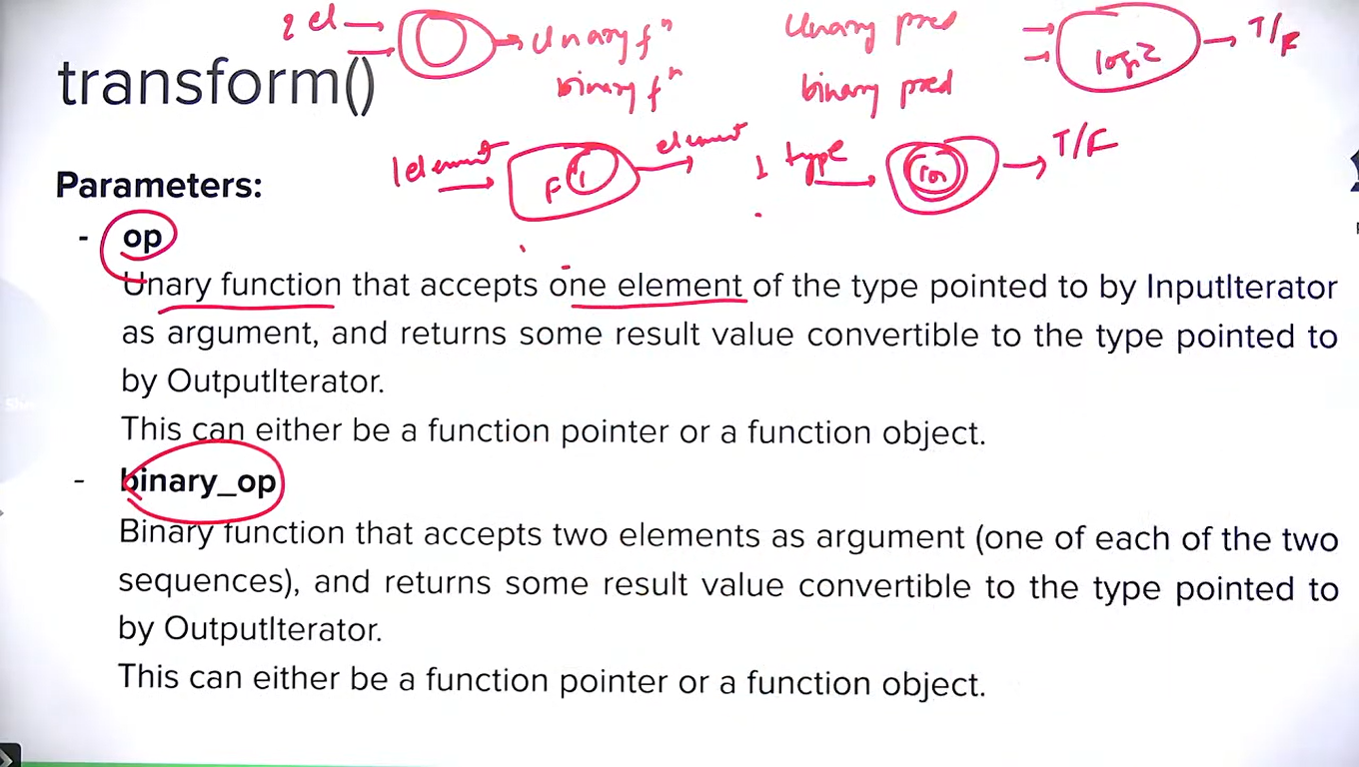

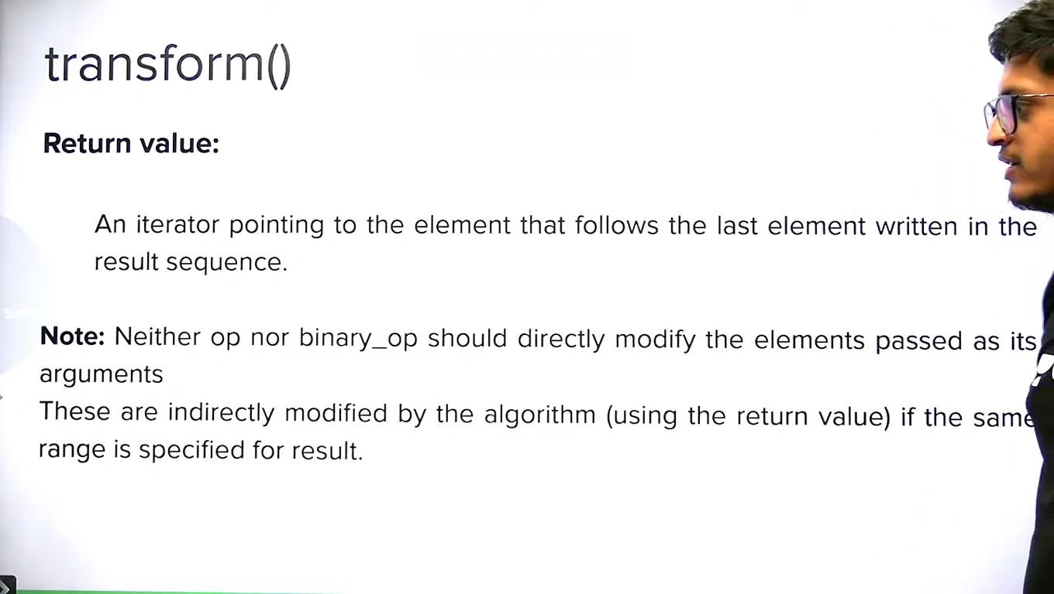

Operation function should not modify the elements so better make it constant and pass by reference.

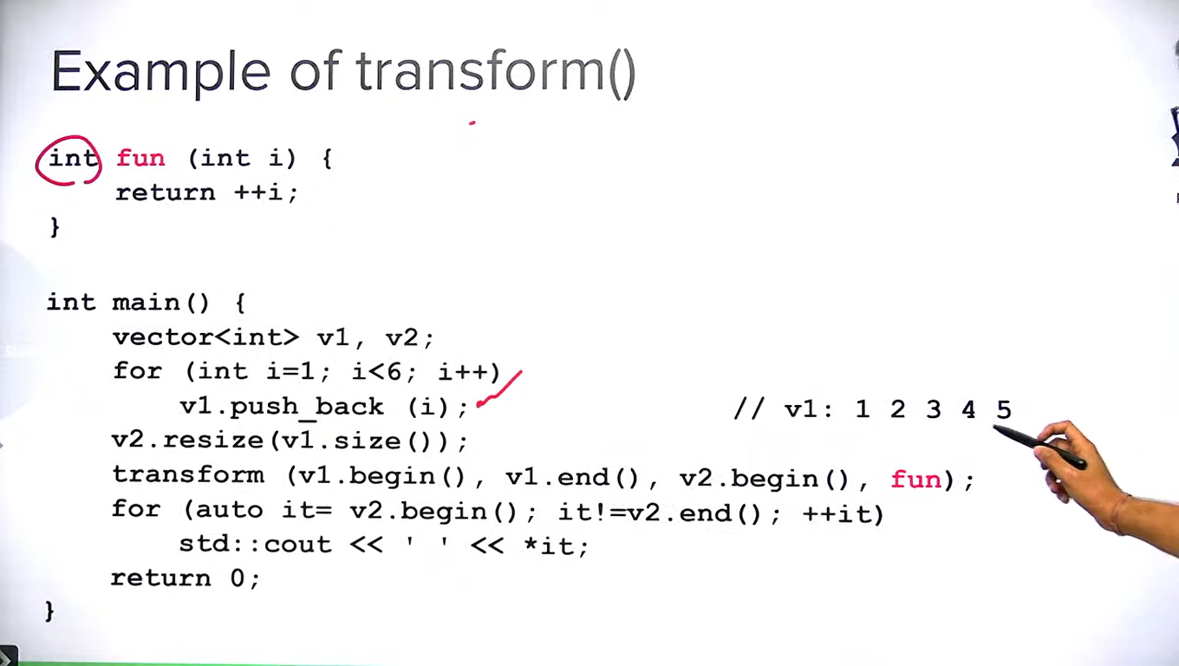

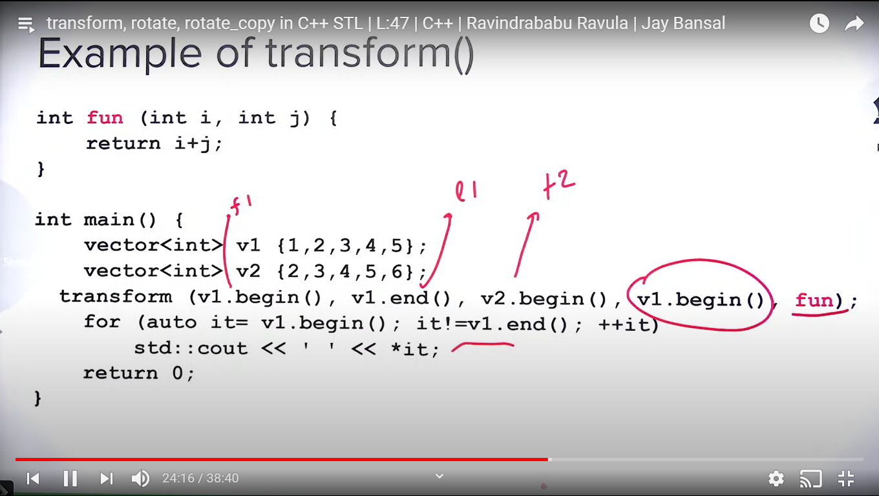

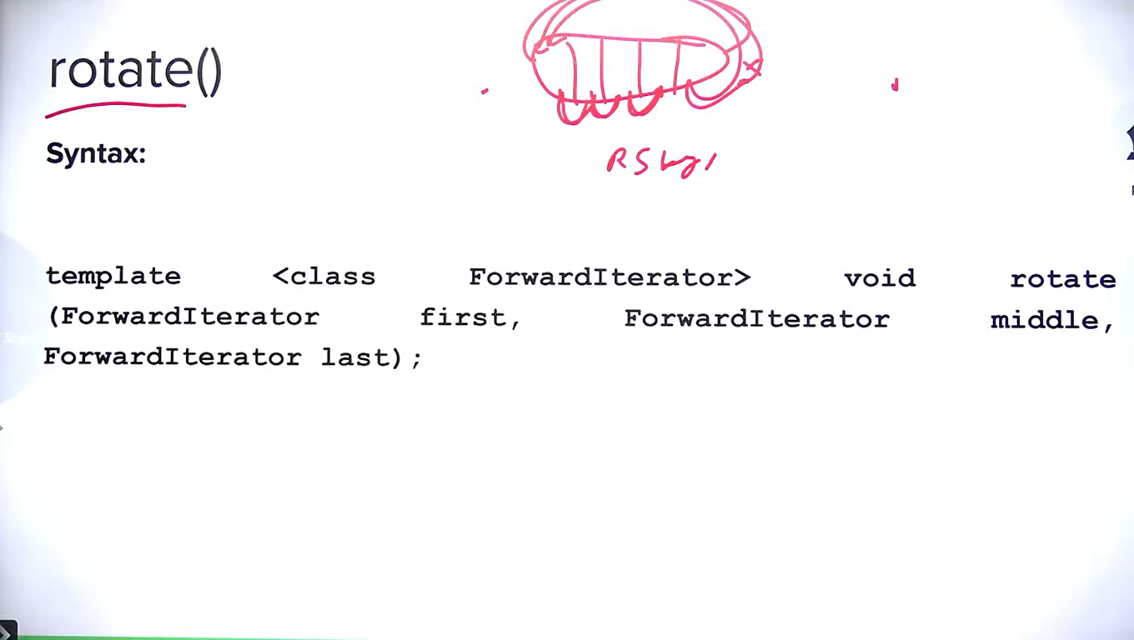

We pass three iterator. Rotation makes middle iterator element as first element.

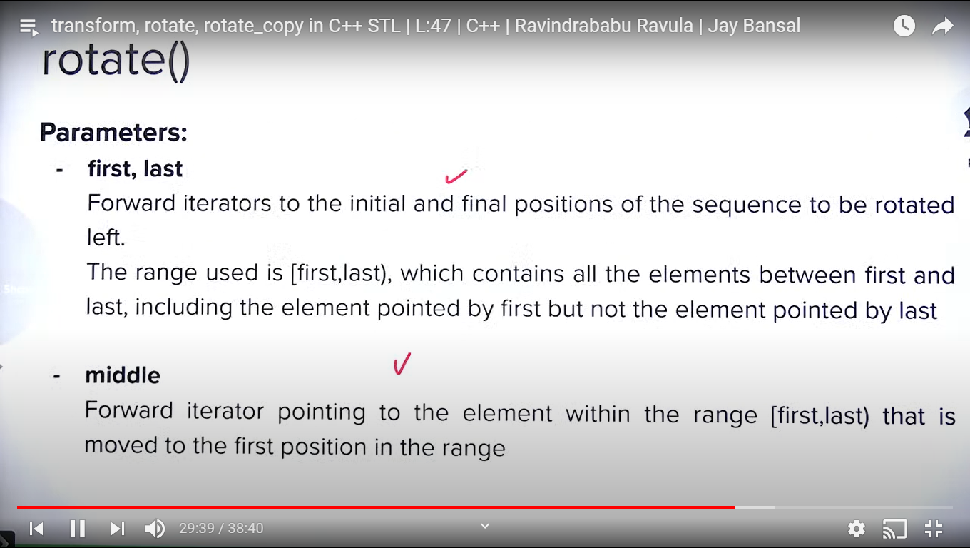

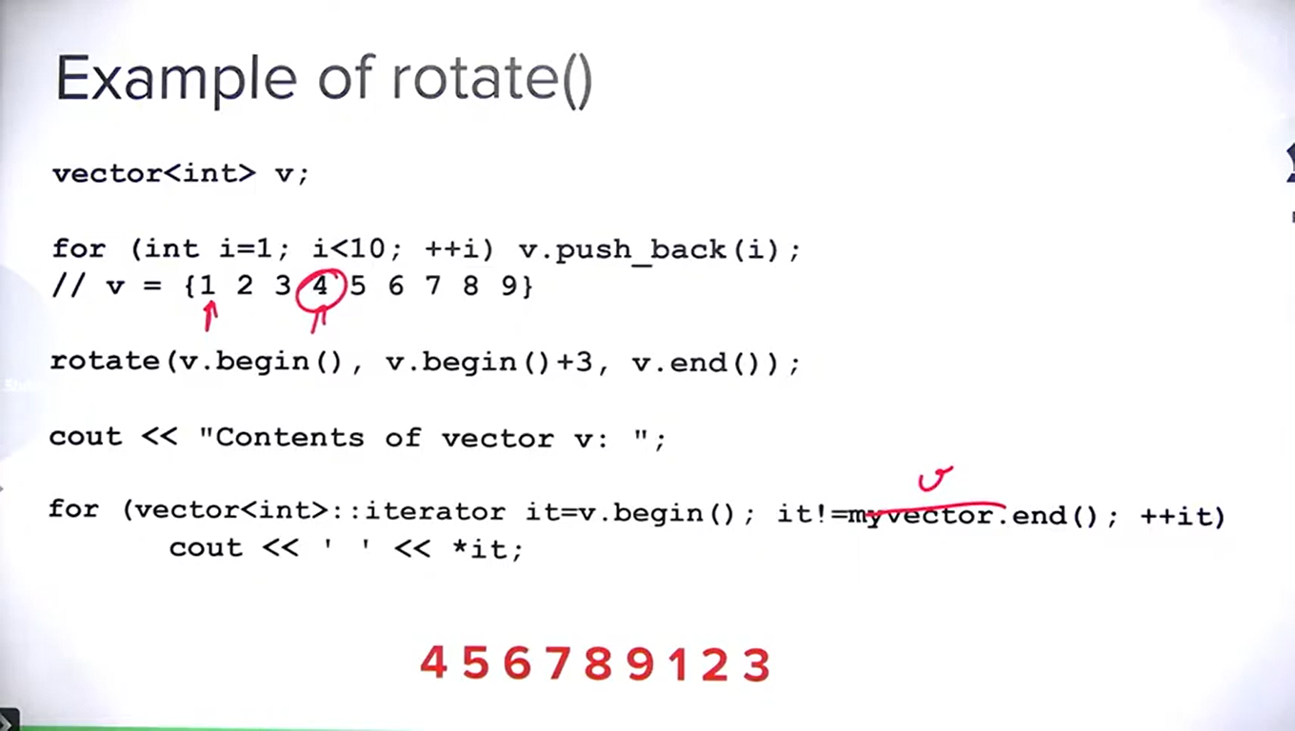

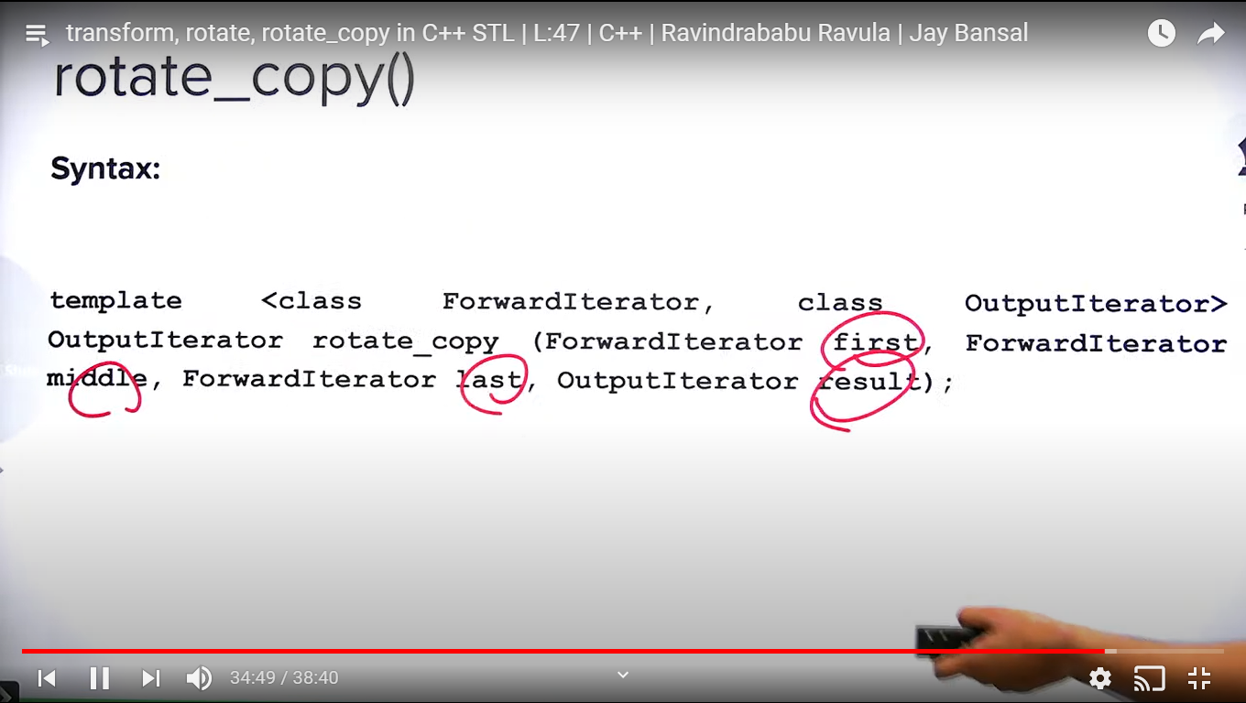

**Random_sample() and random_shuffle():**

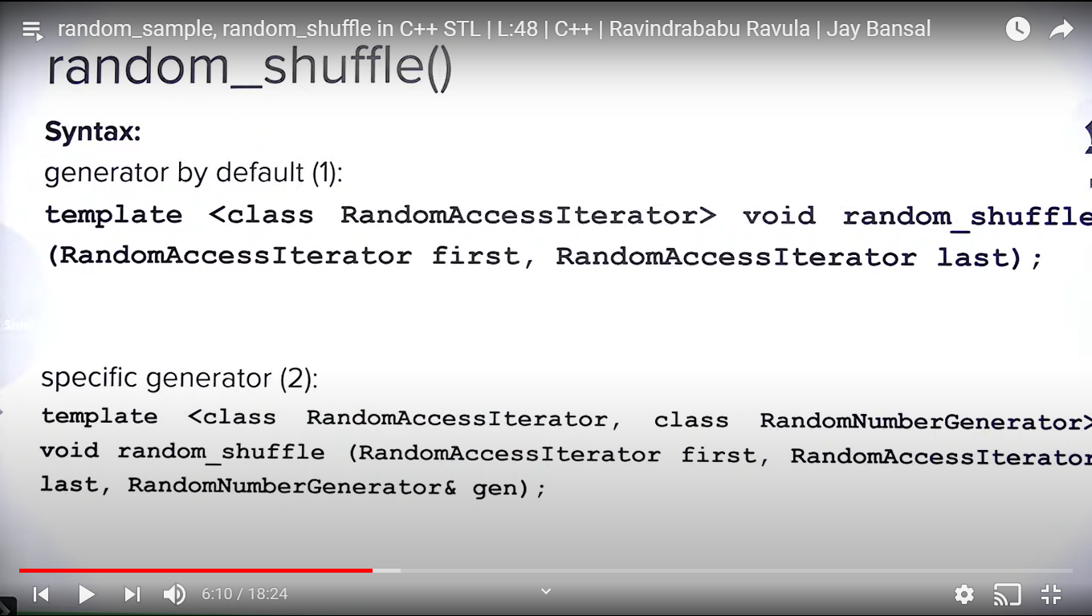

Random_shuffle uses rand() functions internally and s_rand() sets the seed for rand() function.

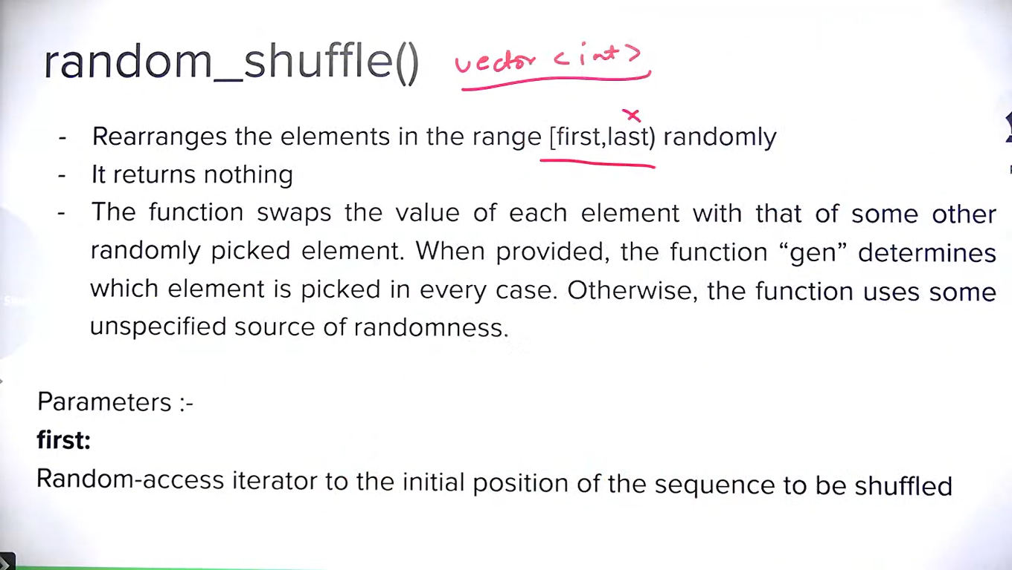

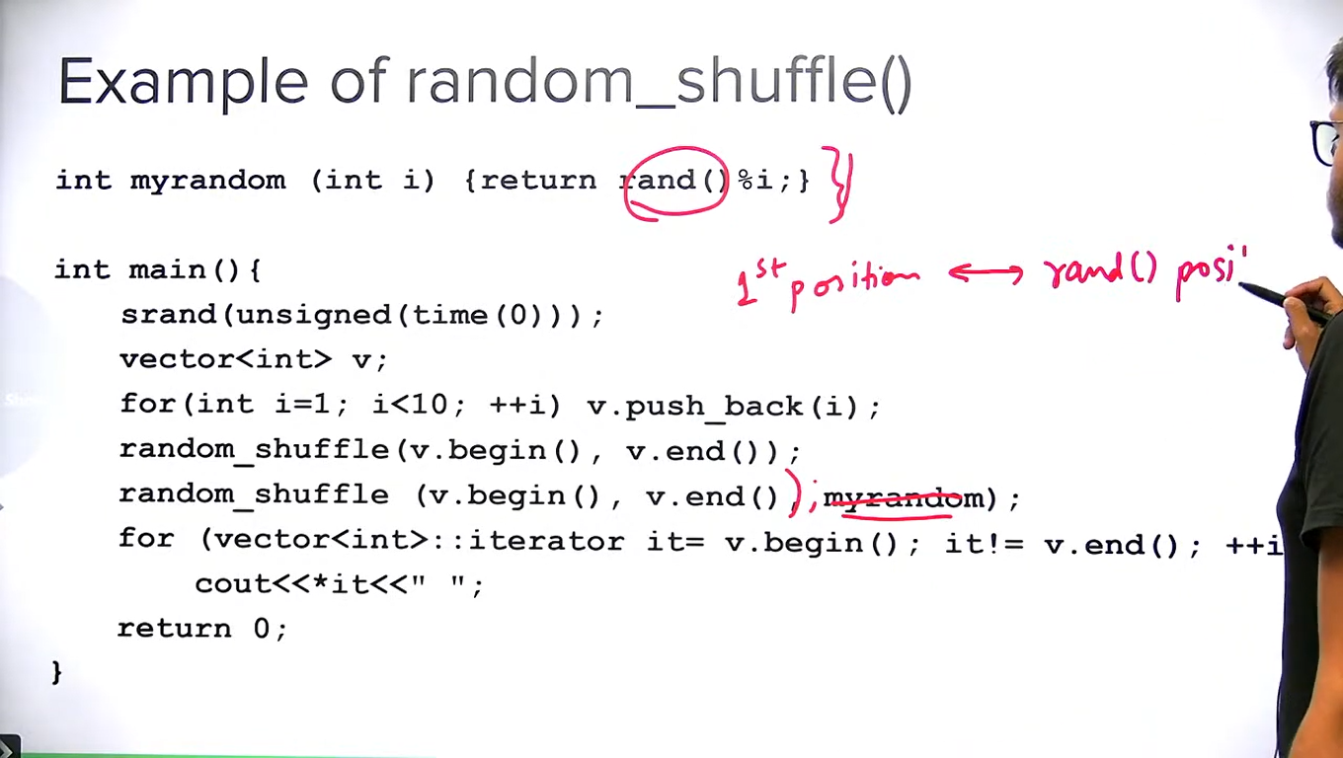

Every position is swapped with some random position.

It calls rand() function internally.

If rand() function is not used seed set the it generates random number always but if seed is set then it generates number of sequence.

Random_shuffle uses rand() function with set seed. S_rand() is used internally to set seed.

We need seed to set as random so that we use system time as seed. This is very generic method to set seed to generate different numbers.

Achieving true randomness is very difficult. So these are pseudo random.

Tossing a coin and throwing is dice are pseudo random and true random.

**LIST IN C++ STL:**

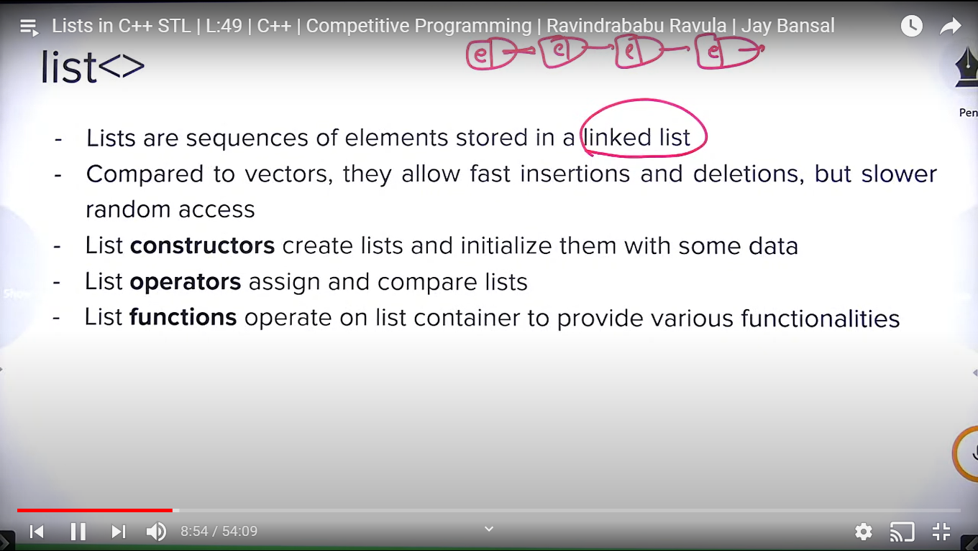

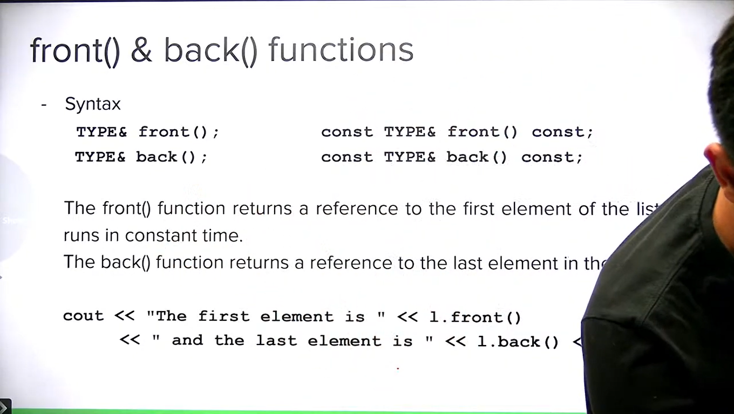

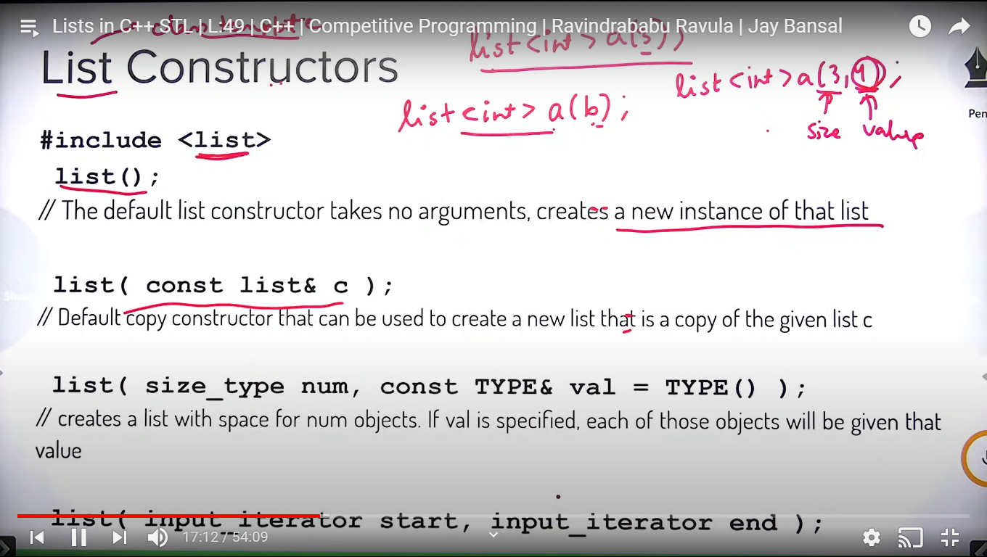

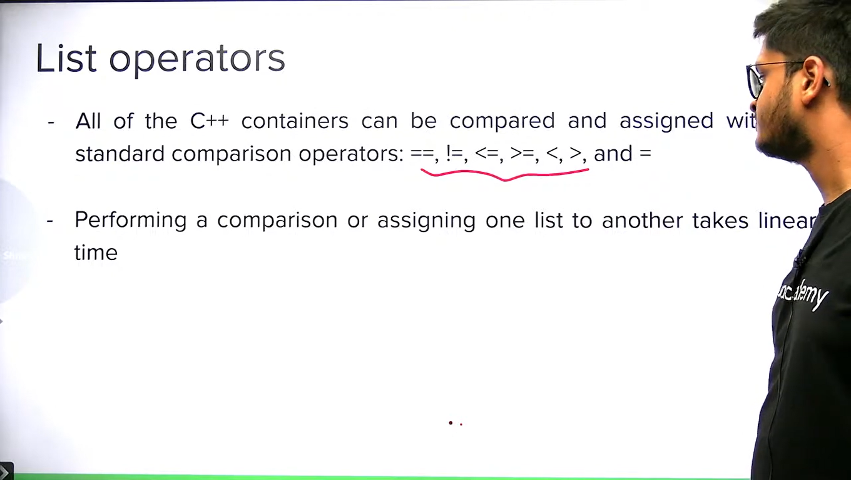

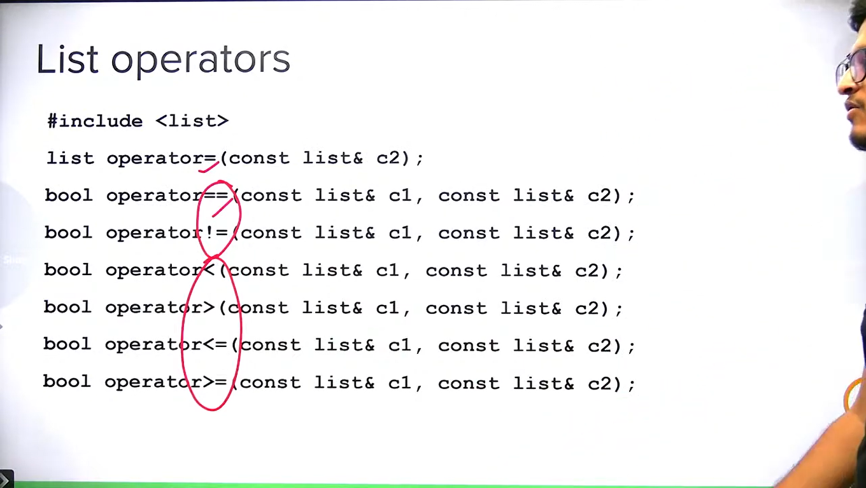

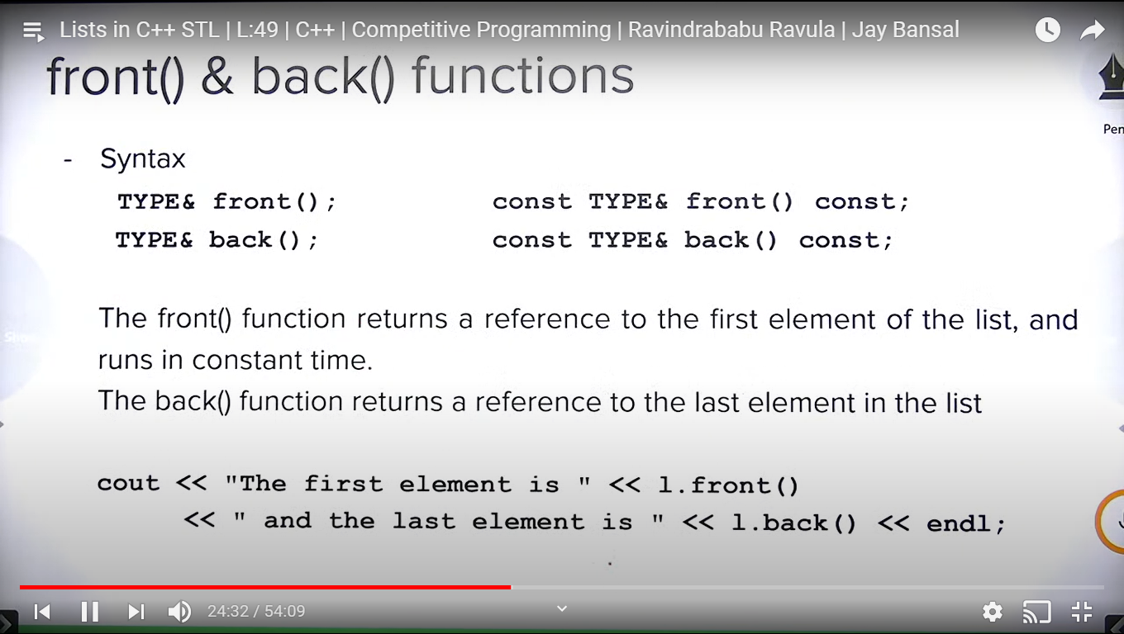

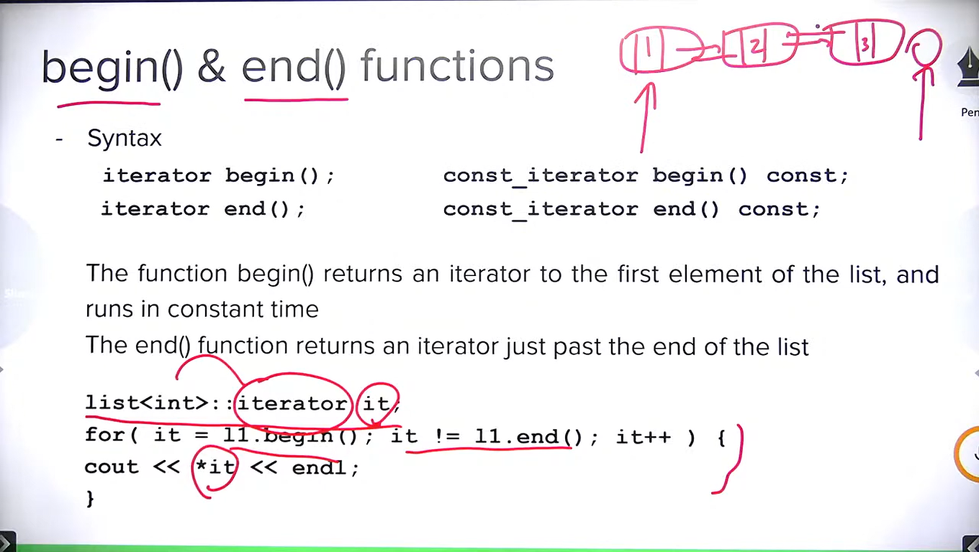

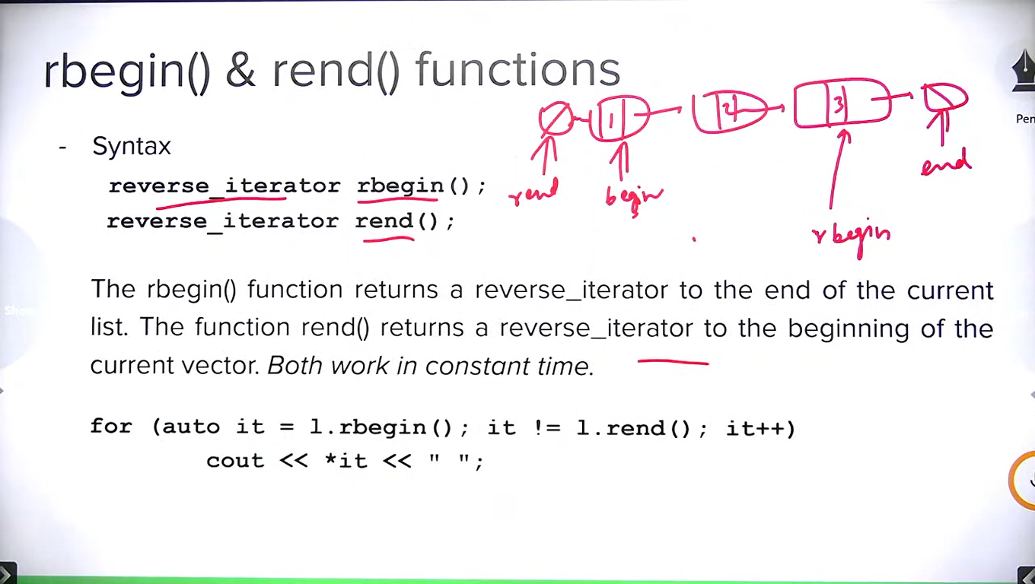

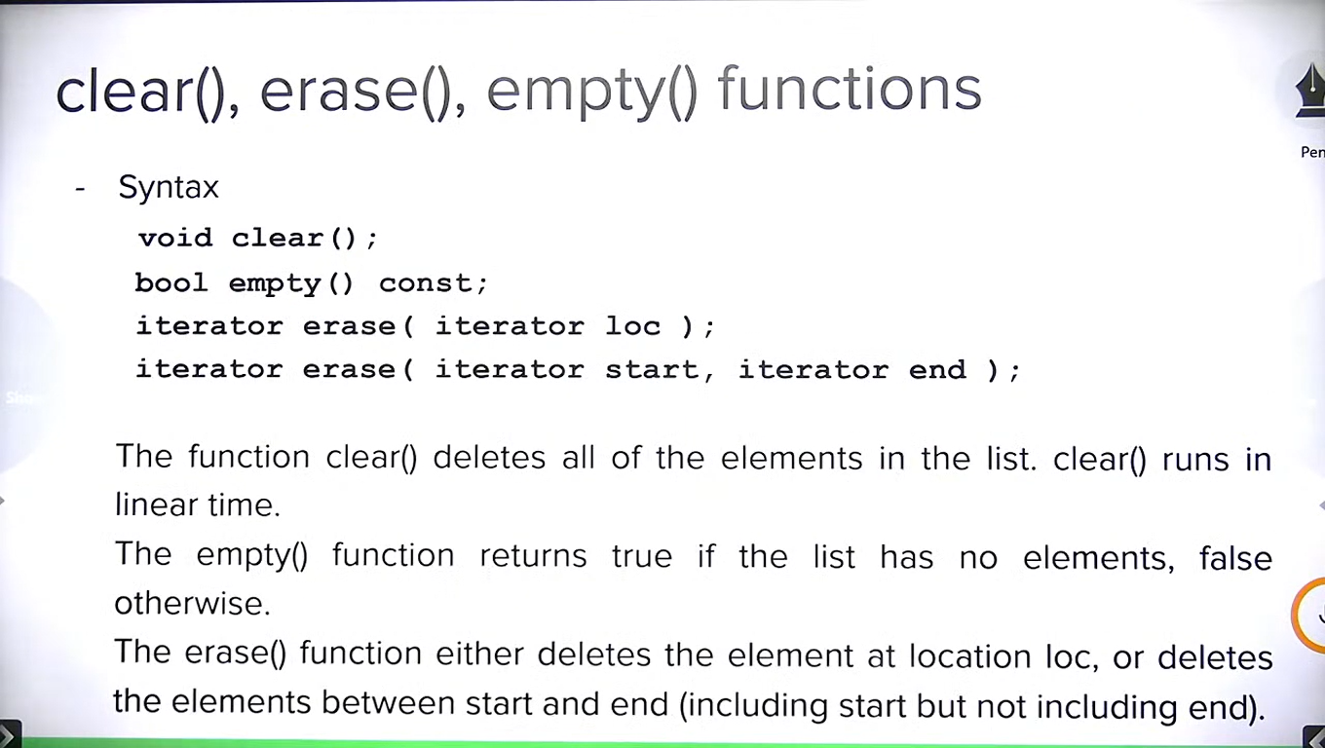

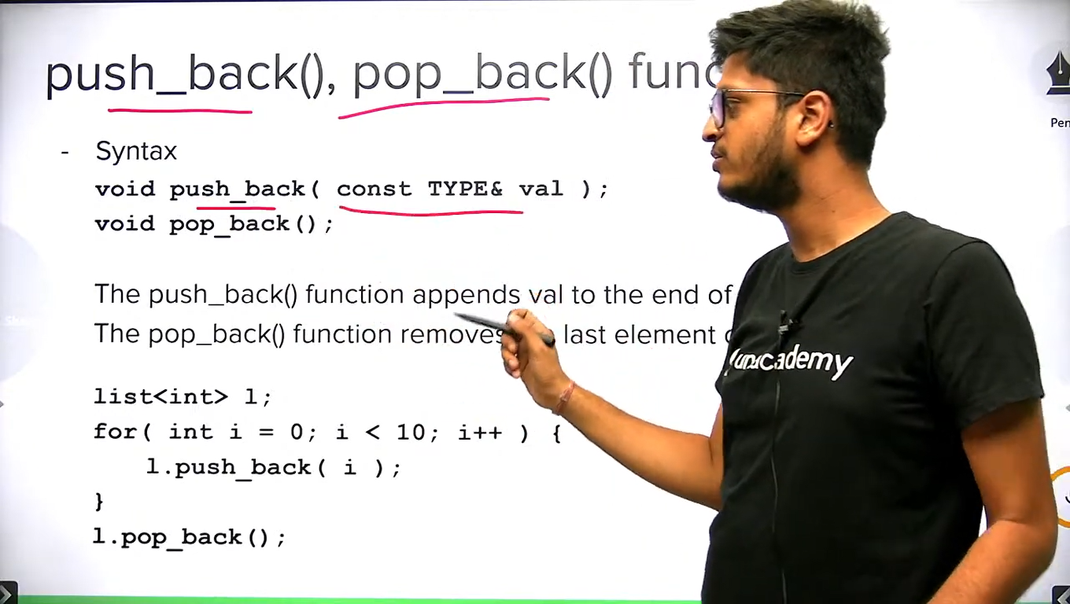

We have push_front() and pop_front() similarly.

In list/vector, we can’t erase an element passing by value. Only iterator and iterator range are supported here.

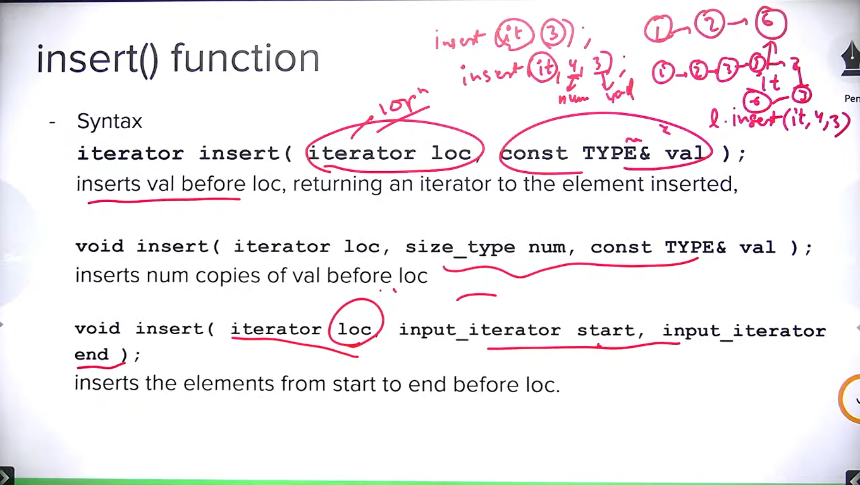

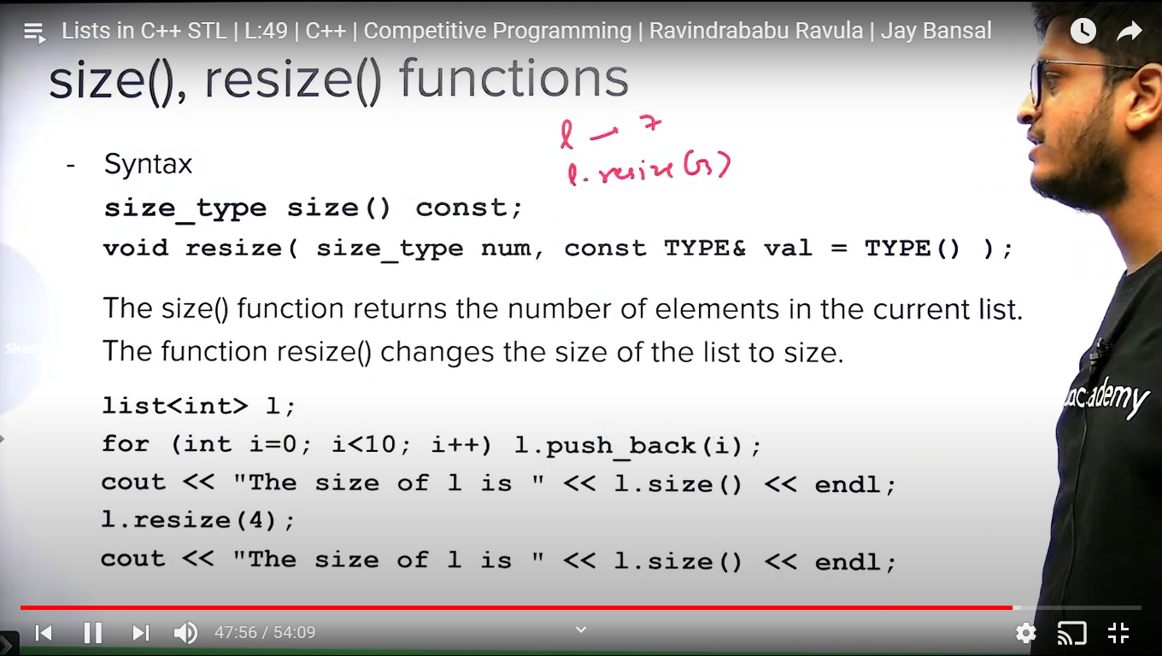

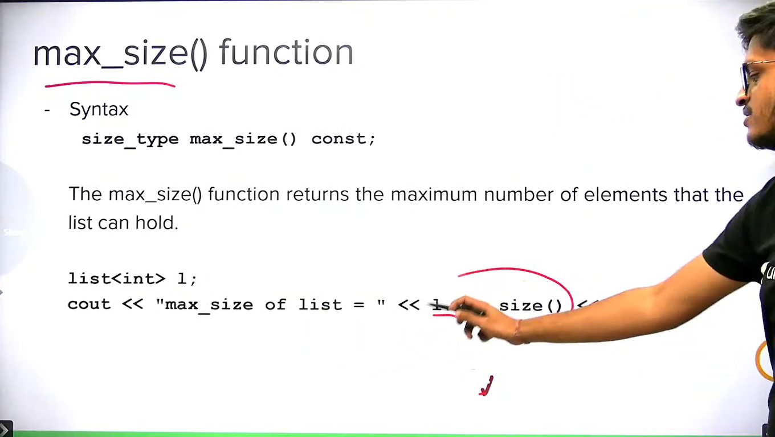

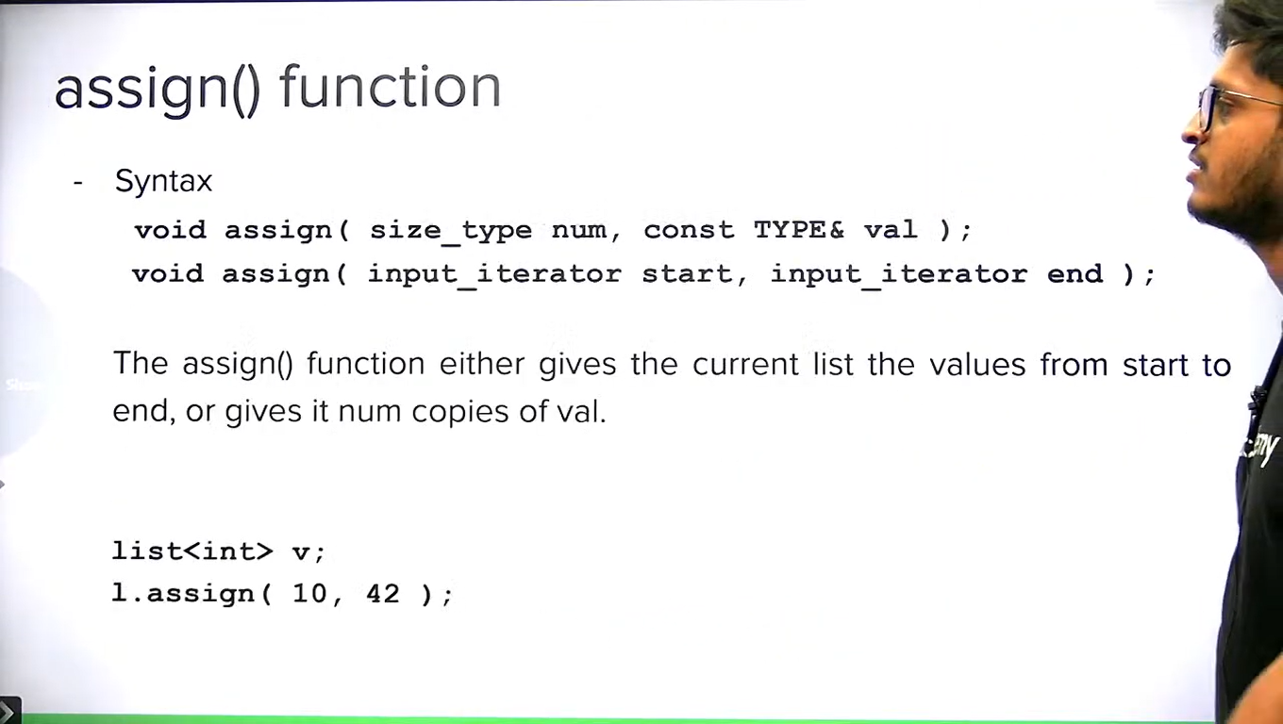

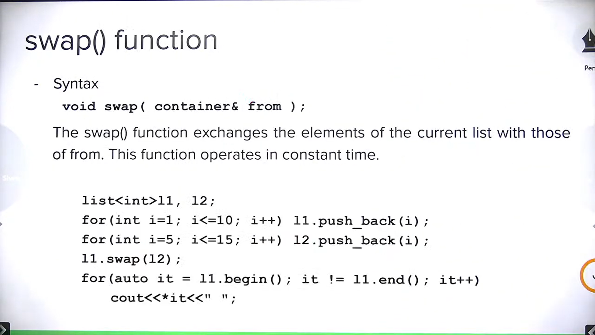

**Note:** iterators/pointers are swapped only, contents are not swapped so it works in O(1) time.